I work in my office with Visual SVN in our software projects and would love to have a version control at our disposal. This is useful for many reasons. If we are working with one or more developer on a joint project, if we have a desktop and a laptop and we want to work from both computers while keeping the files synchronized, or if we just want to be more organized and keep versions and backups of our work. We can also use Visual SVN to synchronize folders or documents between several computers.

Here I give the Software. Please Download these.

[TortoiseSVN-1.5.6.14908-win32-svn-1.5.5.msi](http://downloads.sourceforge.net/tortoisesvn/TortoiseSVN-1.5.6.14908-win32-svn-1.5.5.msi?download)

[TortoiseSVN-1.5.6.14908-win64-svn-1.5.5.msi](http://downloads.sourceforge.net/tortoisesvn/TortoiseSVN-1.5.6.14908-x64-svn-1.5.5.msi?download)

[VisualSVN-Server-1.6.2.msi](http://www.visualsvn.com/server/download/)

This article will have 2 sections One will discuss the SVN Server installation and configuration and the second part will be about how to use the SVN client.

First you have to download the [Visual SVN Server Installation](http://www.visualsvn.com/server/download/)

Or download Visual SVN and Tortoise SVN from the given link.

**Installing the Visual SVN Server**

Double click on the Visual SVN executable to begin the installation. A few next next next clicks you will get this screen to the next.

[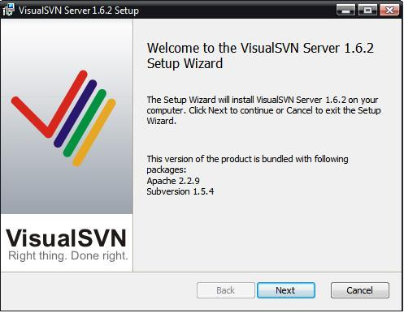](https://rajibmahmud.files.wordpress.com/2009/01/setup4.jpg)

Visual SVN Server

Here you can select the Location of the installation and the Location of the repositories (where the projects will be located). If you are using this installation on a server and intend to access it from different locations you will have to specify a Server Port for the SVN server to use which you will later forward on the router. You also have the option to select the authentication methods either Windows users or specific Subversions users. We will leave everything as is and finish the installation.

This is the Visual SVN Server Manager window.

[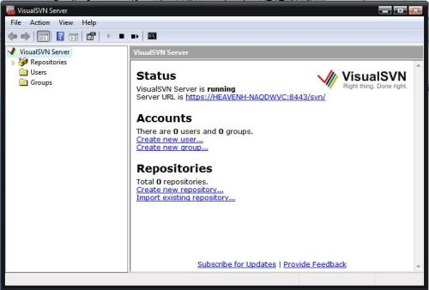](https://rajibmahmud.files.wordpress.com/2009/01/visual-svn-server-manager3.jpg)

Visual SVN server manager window

**Creating a Repository**

Right Click on Repositories and select Create New Repository

[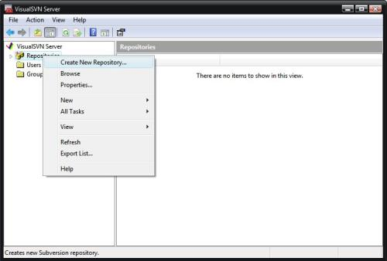](https://rajibmahmud.files.wordpress.com/2009/01/setup62.jpg)

Repository Creation

[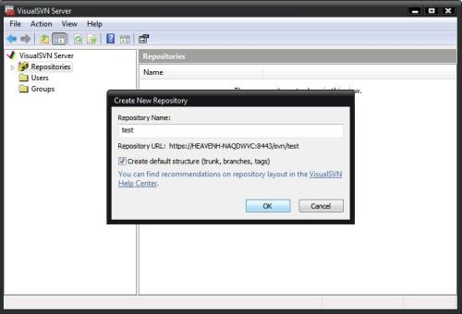](https://rajibmahmud.files.wordpress.com/2009/01/setup71.jpg)

Geting URL

[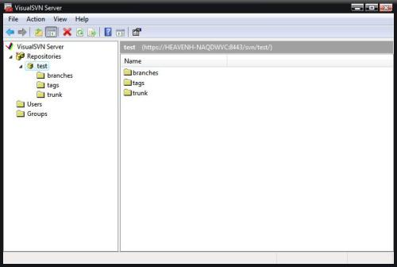](https://rajibmahmud.files.wordpress.com/2009/01/setup81.jpg)

Defult Sturcture

You will be prompted to provide a name to that repository and you will have the options to create a “default structure” which means you will get the trunk, branches and tags folders. for those of you who are familiar with source control trunk is the “Development” main branch, branches are for temporary copies of the main branch and tags are versions of the main development you want to keep for visioning. You can read more about it [here](http://www.visualsvn.com/support/topic/00017/).

After you have specified the repository name click ok and you are all done creating your first repository.

**Configuring Users**

Go to the start menu and run the Visual SVN Server Manage.

Right Click on Users and select Create User

[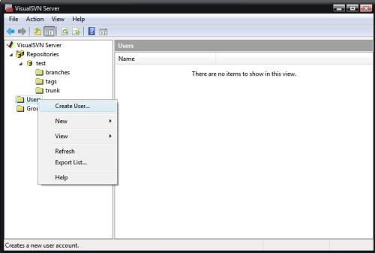](https://rajibmahmud.files.wordpress.com/2009/01/setup91.jpg)

Create User

You will have to specify a user name and passwords click OK and you have your first User!

Remember the repository we created a few minutes ago, now is the time to assign premitions to our newly created user. Right click on the repository and select properties or go to all tasks then select manage security:

[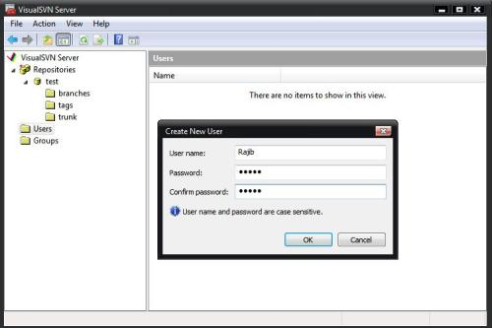](https://rajibmahmud.files.wordpress.com/2009/01/setup102.jpg)

User Password

[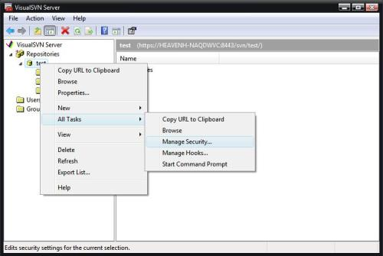](https://rajibmahmud.files.wordpress.com/2009/01/setup112.jpg)

Security Manage Window

You will get the following screen:

[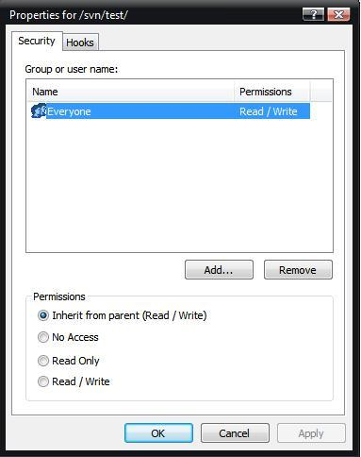](https://rajibmahmud.files.wordpress.com/2009/01/setup12.jpg)

Parmission to all

Click on add and you will see the list of all the users in the system

[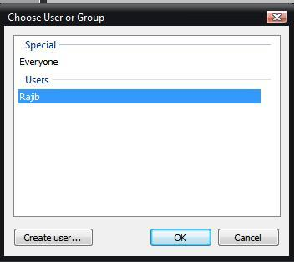](https://rajibmahmud.files.wordpress.com/2009/01/setup13.jpg)

Properties of User

Select the user you want to add permissions and click OK. You can now see that the user Rajib is in the group of users that are allowed to access the SVN server

[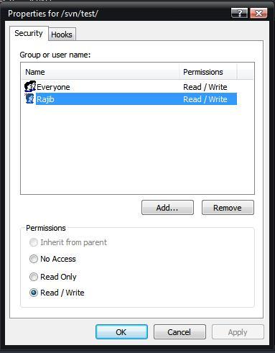](https://rajibmahmud.files.wordpress.com/2009/01/setup14.jpg)

Authorison to different user

That’s it. You now have your own SVN server at your disposal. In the next couple of days I will show you how to work with the Visual SVN Server using it’s client, so don’t forget to Grab our feed and stay updated.

Now we installed and configured the Subversion server using Visual SVN.

**Tortoise SVN Client Application:**

Now I am going to show you how to interact with the server from the client side.

What you will need to download the [Tortoise SVN client application](http://tortoisesvn.net/downloads). Or check the given link at the begening

Download and install and after a restart (bummer) we are ready to start working!

The Tortoise SVN adds its functionality in the Windows Explorer Context Menu.

[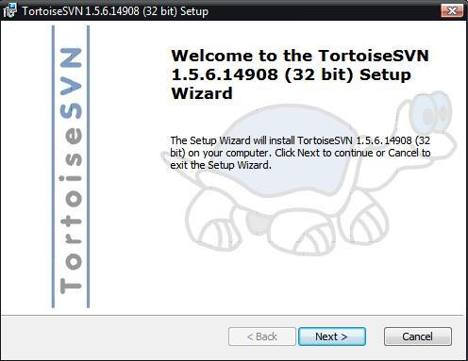](https://rajibmahmud.files.wordpress.com/2009/01/setup15.jpg)

Tortoise SVN Client Application

**Verifying the connection to the SVN Server**

Before we start working we will have to Verify the connection to the SVN Server. Right click on any folder in the Windows Explorer and select TortoiseSVN -> Repo-browser

you will be asked for a path to the repository enter : file:///E:/<The location of the repositories>/<The repository name you selected> in my case I will enter :

file:///E:/Repositories/Test/

[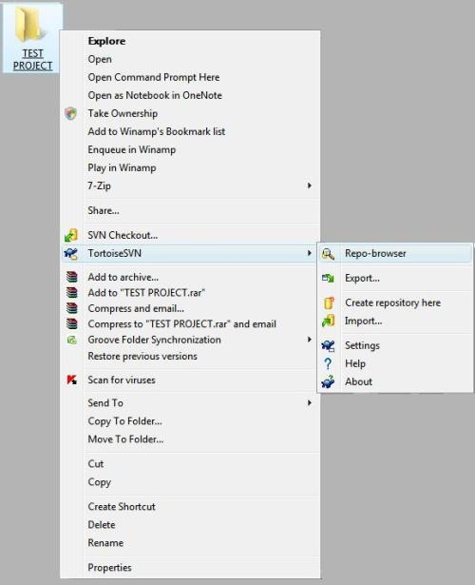](https://rajibmahmud.files.wordpress.com/2009/01/setup18.jpg)

Connection with SVN server

You can get the URL from the Visual SVN Server Manager window like this.

[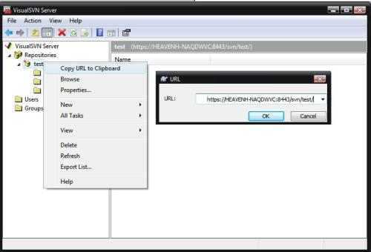](https://rajibmahmud.files.wordpress.com/2009/01/setup19.jpg)

URL

what you should get is this:

[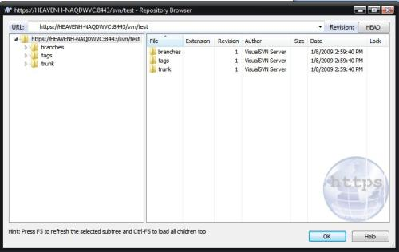](https://rajibmahmud.files.wordpress.com/2009/01/setup20.jpg)

Connection Stablished

If you got this it means that you can connect to the SVN Server.

If you are trying to connect to a remote server you will have to enter the following when asked for the URL of the repository:

https://<The ip of the Server>/svn/<The Repository Name>

You should get the same results.

**Getting the files from the repository**

To get the files from the repository we created earlier, we will have to create a new folder, which I hope everyone knows how to do it.

After you have created the folder, right click on it and select the “SVN Checkout…” option from the context menu. You will see the following screen:

[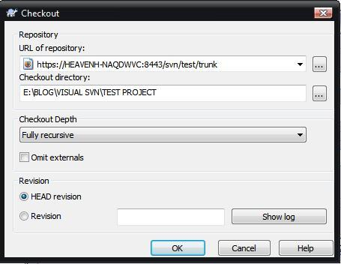](https://rajibmahmud.files.wordpress.com/2009/01/setup22.jpg)

Checkout

[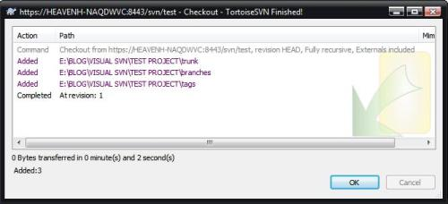](https://rajibmahmud.files.wordpress.com/2009/01/setup24.jpg)

Checkout Completed

If you followed all the steps the address of the repository should be already written here. All you have to do is click “OK”

This means we have checked out the files successfully and we can start working!

The directory should look like this:

[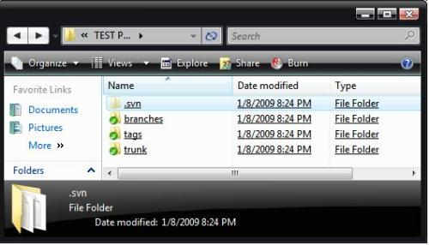](https://rajibmahmud.files.wordpress.com/2009/01/setup25.jpg)

Directory Outlook

The Green V marks mean that nothing has changed inside the directory. Let’s add a new file to the trunk (main branch) directory. We will then Right Click on the trunk and select “Commit”

[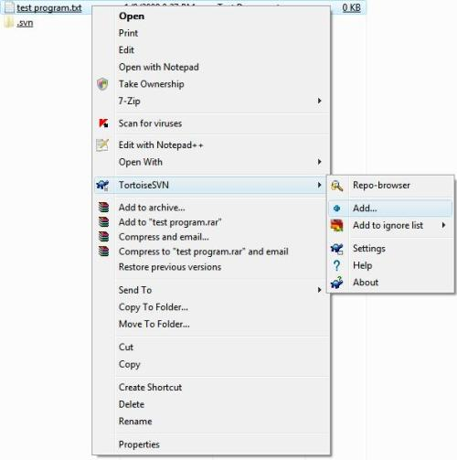](https://rajibmahmud.files.wordpress.com/2009/01/setup26.jpg)

File Add to SVN

[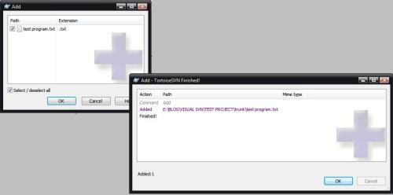](https://rajibmahmud.files.wordpress.com/2009/01/setup27.jpg)

Adding complete

The SVN Server has detected that you have added a new file and you will have to check the Checkbox next to it in order for it to be inserted to the repository.

Lets try and edit the file and add some text in it. Both the file and the Directory will get a red exclamation mark saying they have been changed:

To send the Changes to the Server you can right click any of them and select “SVN Commit…” from the context menu. Doing it on the Folder will make the Commit recursive to all the files inside it.

That’s it! You are ready to work with you very own version control. In my next post I will show some advanced features of the SVN system.

[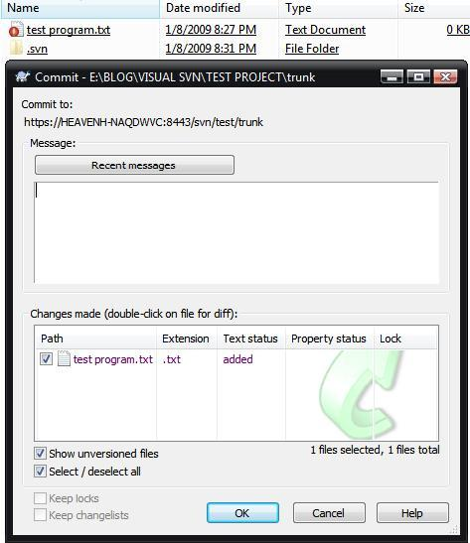](https://rajibmahmud.files.wordpress.com/2009/01/setup28.jpg)

SVN commit

[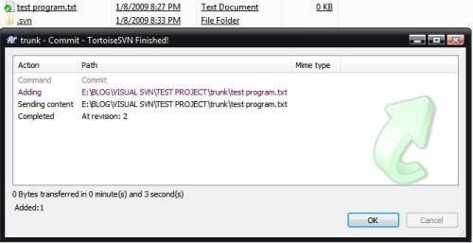](https://rajibmahmud.files.wordpress.com/2009/01/setup291.jpg)

Commit complete

But this is a good practice to update your work fast before commit. For update your work follow the procedure given bellow.

[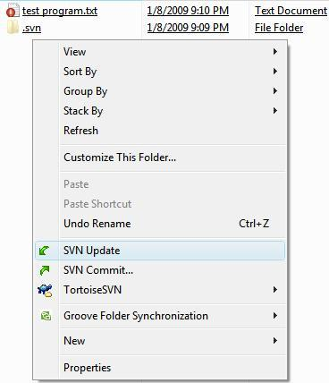](https://rajibmahmud.files.wordpress.com/2009/01/setup30.jpg)

SVN Update

[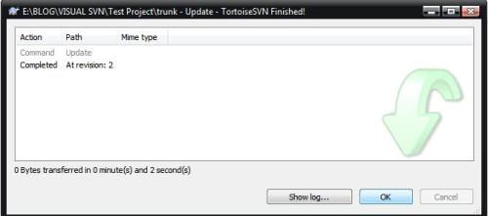](https://rajibmahmud.files.wordpress.com/2009/01/setup31.jpg)

Update complete

Thank you for read the procedure. I hope you will get benefit using Visual SVN and Tortoise SVN. I am waiting for your comment.